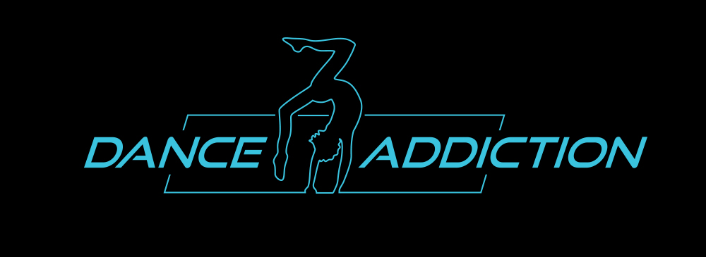
2020 Dance Addicts Handbook

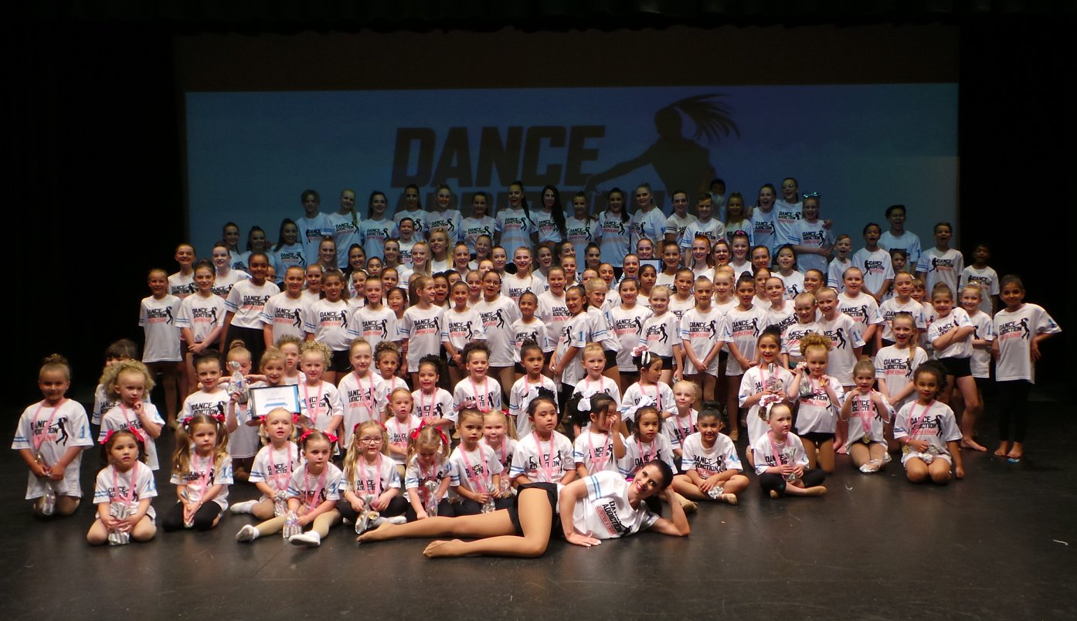
Dance Addiction Studios
(T/A Dance Addiction)
Unit 6/2-6 Tulloch Way, Canning Vale WA 6155
www.thedanceaddiction.com.au
admin@thedanceaddiction.com.au
0423 084 820
ABN – 7462 949 6410

About Dance Addiction
It’s our absolute pleasure to warmly welcome you into our Dance Addiction family. Our team is thrilled to see many familiar faces return to the studio and even more excited to see some new faces join our community. We have created this one-stop handbook to hopefully shed some light on how things will run throughout the year as well as answer a lot of queries you may have before the year begins. While we would love you to take the time to read this information carefully and keep your handbook in a safe place to refer to as you need, don’t forget that our friendly office staff are always here to help and will happily answer any queries you may have. Nothing is too big or too small, we promise! ☺

Who We Are
To start us off, it’s important to us at Dance Addiction that all members of our team share our vision, our purpose and the philosophy that encompasses everything we do both in and outside of our classes. This is a vision that is shared and demonstrated by the directors, teachers and staff members at our studio and it is the driving force behind every interaction with our students and their families.

Dance Addiction is a place where children of all ages and ability learn to dance, sing and perform. This is a studio where creativity, individuality and self-expression is encouraged and has a community of teachers, students and families who are passionate about dance and performing arts. Our goal is to create a positive and happy experience for all our students. We strive to nurture and develop talent, celebrate the achievements of all students and inspire a love and appreciation of all styles of dance and the arts. We are committed to providing a safe and positive environment in which all students can feel empowered, comfortable and free to express themselves, whilst receiving quality training.

Registration
Before hitting the dance floor, it’s important that all students and/or parents – whether returning or new - fill out your online registration form so we can ensure we have the most up-to-date contact details for you. This information includes your registration form, media release form (so we can show off photos and videos of our amazing dancers in and around the studios), and your code of conduct.

Communication
By now you have probably noticed that we are BIG on communication here at Dance Addiction, it is our promise to respond to all enquiries within 24-hours and we will never leave a query unanswered. Our team can be reached at admin@thedanceaddiction.com.au or call Christian at 0423 084 820.

For convenience, our primary means of communication is via email. You will receive regular newsletters and important information via email so please ensure you have provided the studio with an up-to-date email address that is regularly checked. We are of course happy to include multiple email addresses per family if you would like your correspondence sent to numerous recipients. Don’t forget to add our email address (admin@thedanceaddiction.com.au) to your contacts so we don’t end up in the dreaded Spam folder!

In the infrequent case of urgent information (for example, unexpected class cancellations or performance changes), we will send an SMS and/or telephone to all families. So, for this reason, please make sure the mobile phone number you have provided to the studio is correct and up-to-date.

Facebook is a great way for us to keep in touch with a large number of people at once, so we encourage all families to join our closed Dance Addiction Facebook group. This group can be found at https://www.facebook.com/groups/2984305274934933/ and will be monitored to ensure all content is appropriate and relevant.

We always display important information, dates and studio details in reception so please have a quick look when dropping off and picking up in case there is anything you may have missed. We are always happy to chat in more detail about communications you may receive from the studio, so if you need any clarification please don’t hesitate to call us on 0423 084 820 to chat with one of our helpful team members.

Important Dates
We understand wholeheartedly how busy the lives and schedules of our dance families can get as the year rolls on, so we have tried to get all of our important dates organised and ready for you so you can plan other commitments. Below we have listed some of our most important “Save the Dates” with more information (including times, costumes, requirements, etc.) to be communicated via email and Facebook as we get closer to the events. If you know ahead of time that your family will be unable to attend these events due to planned holidays or existing commitments, please let reception know at your earliest convenience.
Term Dates
- Term One – Monday 3 February to Saturday 11 April (10 Weeks)
- Term Two – Monday 27 April to Saturday 4 July (10 Weeks)
- Term Three – Monday 20 July to Saturday 26 September (10 Weeks)
- Term Four – Monday 12 October to Saturday 19 December (10 Weeks)
Competitions
Dance Addiction will be attending the following competitions in 2020 for solos and duos.
- On Stage Performing Arts Competitions
  - Friday 17 April – Sunday 26 April @ Penrhos College (Rixon Theatre)
  - Friday 25 September – Sunday 4 October @ Penrhos College (Rixon Theatre)
- Dance Quest
  - Saturday 23 – Sunday 24 May @ Swan Park Theatre (Midvale) – DUOS/TRIOS
  - Wednesday 27 May – Monday 1 June @ Swan Park Theatre (Midvale)
- Winter Competitions
  - July School Holidays – Dates TBA
Annual Concert Dates
- Stage Practice – TBA
- Dress Rehearsal – TBA
- Concert – TBA
*The 2020 concert & all rehearsals will be held at the Swan Park Theatre in Gray Drive, Midland.

Classes
Dance Addiction caters for students interested in simply dancing for enjoyment or for those who wish to take their dancing more seriously. Competition, troupe and Examination classes are available in all genres.

We encourage all of our students and families to try a variety of dance styles and we are more than happy to accommodate trial classes for existing students who are wanting to try something a bit different. Please contact reception if you would like to try a new class and we will happily schedule a quick meeting and fit you in for a trial (provided the class has not reached capacity). Our current styles offered are:
- Modern/Jazz
- Acrobatics
- Classical Ballet
- Kindy Dance
- Hip Hop
- Tapping
- Lyrical
- Contemporary
- Musical Theatre
- Examinations
- Competitions (Solos/Duos/Trios)
- Company Classes (Competition Team)

Safety
With the safety of our families a number one priority, Dance Addiction is very serious about upholding Child Protection laws and policies within the studio as well as at public performances and in the online arena (website and social media).
As part of your registration, you will have read and signed a media waiver allowing us to proudly use images and video footage of your student for advertising and promotional purposes. Should you have any concerns whatsoever with signing this declaration, please see our reception staff who will happily assist you.
The directors and staff at Dance Addiction are educated in the negative impact of inappropriate music and costume selection when it comes to performing dance routines and are wholeheartedly committed to ensuring children in all of our dance routines are not subjected to any inappropriate songs or costuming. We recognise that songs with sexist, explicit, violent, racist, homophobic or criminal content may influence our dancers and/or audience and will strive to avoid using such music. We are committed to restricting costumes that project sexuality, contain explicit graphic or textual content.
Dance Addiction takes no responsibility for any stolen or misplaced property on the studio premises and we encourage our families to avoid bringing valuable items into the studio where possible.

Privacy
When you purchase or hire a product or service with Dance Addiction the information we may collect from you includes your name, address, telephone numbers, email addresses, medical information and perhaps credit card or bank details. It may also include details of the products and services we provide to you as well as the status of your enrolment. We only collect information directly from our students or their parent/guardians primarily for the purpose of providing services and products to you and to administer and manage invoicing and debt collection.

We may occasionally use your information to promote and market to you information which we consider may be of interest to you unless you contact us and tell us not to do so.

We will never sell or pass on any of your information to third parties unless required by government authorities or in the event of debt recovery. Any information passed on will be done so with appropriate privacy and confidentiality protection.

Information is stored securely in paper or electronic form and is accessible only by authorised personnel.

If you would like to know what information we hold about you or wish to update the information, or if you wish to be removed from all further direct marketing communications, please contact our Reception.

Timetable
Timetabling our classes is a huge task and we take all care to ensure that children are given classes at an age-appropriate time without long hours that may lead to fatigue or disrupt home / school life. Our timetable for 2020 is available in this registration pack or on our website. Please contact us if you have any questions at all.
Fee Information
Dance Addiction prides itself on being an affordable option for those who are passionate about dancing. We understand everyone is on a budget and strive to offer affordable options regardless of what you want to achieve with your dancing.

All classes are taught by fully qualified teachers with experience in the industry with class sizes kept to a level that allows for a lower student to teacher ratio so that your child receives the highest quality training.

An annual enrolment fee ($40 per student) is charged to cover administration, insurance, and relevant music licencing. Additionally, a concert rehearsal fee is added to all Term Four accounts. Costumes must be paid for during the year, with small compulsory instalments commencing in Term One.

Fee Structure
- 45 Minute Classes - $130/ea per term
  - Modern/Jazz, Tap, Acrobats, Lyrical, Contemporary, Classical, Hip Hop, Musical Theatre & Examination classes.
- Kindy Classes - $80/ea per term
- Private Classes (Not Included in Class Packages)
  - $35ea (30 minutes)
- All additional competition & examination entry fees will be charged separately.
Packages/Discounts
- Class packages are available for students doing multiple classes. Class package details are available on our pricing list for 2020.
- Discounts are not available on private classes.
Payment Options
- Families will be invoiced at the beginning of each term.
- Fees can be paid by
  - Direct Debit – We can set-up direct debit payments for you (fees apply).
  - Bank transfer (BSB: 016 370 ACC: 216672236 Reference: Family Name)
  - Credit Card @ Studio (Fees apply)
  - Parent Portal (Bank or Credit Card Payments – Fees Apply)
  - Payment Plans are available, please see Reception.
- Missed classes or withdrawals from a class during the term, are not refundable.

Medical Issues
Please ensure that your Dance Addiction teachers are aware of any medical conditions your child may have. If you have not listed these on your enrolment form, please ensure you update the relevant sections in your parent portal.

Code of Conduct
All families at Dance Addiction must sign the Dance Addiction Code of Conduct before attending classes. Dance Addiction strives to build a positive and welcoming environment for your children and as such has a strict Code of Conduct to assist us in ensuring your dancing studio environment is the best possible for your children to achieve the best results.

Uniform Requirements
At Dance Addiction, we believe that wearing studio uniforms give students a sense of belonging to our family as well as creating an identity for our studio in the greater community.
Our uniforms also:
• Encourage discipline
• Help students resist peer pressure to buy stylish clothes for class
• Help identify non-students in the studio
• Diminish economic and social barriers between students
• Increase a sense of belonging and school pride
• Improve attendance
Uniforms can be purchased year-round from the studio. For a complete price list, please contact reception or visit our website.
Please ensure all parts of your child’s uniform are clearly labelled - individual shoes, socks, etc...you’ll be amazed at the amount of lost property we generate!
Further style-specific uniform requirements are as follows:
Ballet- Ballet students must have full sole ballet shoes which can be purchased from any dance shop. You will also need pink ballet stockings and a Dance Addiction leotard.
Jazz and Tap- Students require black/tan jazz and/or tap shoes with socks. For their uniform, students may wear any combination of shirts, crop tops, shorts or pants from our uniform range.
Hip Hop- Students require any pair of sneakers, along with any combination of shirts, crop tops, shorts or pants from our uniform range.
Lyrical/Contemporary- Students can wear bare feet, half soles or ballet shoes for this class. Students also require any combination of shirts, crop tops, shorts, pants or leotard from our uniform range.
Acrobatics- Students do not need footwear for this class (however acrobat shoes are recommended). They must wear tight fitting clothing from our uniform shop with their hair tied back so that they cannot get it caught or tangled in any way when they are doing their tricks.

Parents Watching Classes
Parents are not allowed into the dancing studios at any time to watch classes. This rule does not apply to Kindy Dance classes. Parents are encouraged to either drop your children off and pick-up promptly or make use of our student/parent waiting room upstairs. There are a variety of opportunities for parents to watch classes:
- Viewing Weeks – all classes are open for parents/family to watch on the following weeks
  - Term One (Saturday 6 April to Friday 12 April)
  - Term Two (Saturday 29 June to Friday 5 July)
  - Term Three (Saturday 21 September to Friday 27 September)
- Stage Rehearsal and Dress Rehearsals are open to parents only
- Private competition lessons are open to parents.

Attendance
Your child’s attendance in class is very important to their peers and our teaching staff. As a member of the team, it is a commitment for you to ensure your child attends their classes on time each week and attends all lessons planned for them. Not only do absences impact the concert routines we create, it also impacts the social and confidence-building principals we work hard to foster in each age group.
If you know ahead of time that your child will be absent due to holidays/vacations, commitments or school trips, please let us know ahead of time so the class impact is minimal. If your child is too unwell to attend class, we ask that you inform our admin team as soon as you can so they can let the teachers know and preparations can be made to catch up on any missed work.
Unfortunately, we are unable to accommodate make-up sessions for students who miss classes, but will make every endeavour to schedule a catch-up class in the unlikely event that Dance Addiction needs to cancel a lesson.

Social Media Policy
Dance Addiction’s Social Media Policy refers to all social networking sites, video/photo sharing sites, blogs, micro-blogs, wikis, podcasts, forums, instant messaging and geo-spatial tagging (for example, Facebook check-ins). Please see below for our regulations regarding Social Media and feel free to contact our office staff if you have any questions.
- Please remember that your anonymity on Social Media is never guaranteed and to exercise particular caution when posts, images or videos identify children in your care.
- Remain mindful that your behaviour on Social Media remains in keeping with Dance Addictions code of conduct as outlined in chapter 6 of this handbook.
- Any comments or posts perceived to be obscene, defamatory, threatening, harassing, discriminatory or hateful towards Dance Addiction staff, students or families may subject the owner to disciplinary or legal action.
- Should you wish to engage on Social Media while identifying as a studio volunteer or employee, you may only do so with integrity, respect, and adhere to privacy and confidentiality policy.
- Any content revealing or referring to sensitive studio information is not allowed to be shared online.
- Intellectual property laws (for example, costume design and choreography) must be observed by all studio patrons when posting online.
- While affiliated with our studio, (for example, images of your child Dance Addiction uniform) we will not tolerate any posts that are racially, sexually, physically or religiously offensive.
- All matters pertaining directly to the studio - whether it be fees, scheduling, placements or performance opportunities - may not be communicated via Social Media. We have an open-door policy and encourage all communication, complaints and feedback to be communicated to the principal directly.
- We discourage parents / students and teachers from becoming ‘friends’ or ‘followers’ on Social Media, unless there is an existing relationship. We consider all studio members to be family and as such feel the obligation to respect and monitor personal boundaries.
- Families found to be engaging in ‘hidden’ or ‘private’ groups formed for the specific purpose of discussing studio matters will be encouraged to join our closed Facebook group for public discussion and warned against discussing Studio matters in their private online groups.
- You may not post photographs / videos that feature Dance Addiction dancers other than your own online without the proven consent of their parent/guardian.
- Identifying information of any featured minors - including names, ages or location - must be removed when posting on Social Media.
Competition Requirements
Dance Addiction offers all students the opportunity to do competitions. We have a strong emphasis on participation and personal growth on and off stage for our competition students. If you would like to take part in our competition team, we encourage you to speak to the Dance Addiction staff at any stage of the year. Competitions do require extra commitment and there are a few requirements for those who are art of competitions:
- All students who are enrolled to do competition solos at Dance Addiction must also be enrolled in a ballet or floor barre class (preferably both).
- You must be enrolled in an equivalent class for any competition genre you are dancing (i.e. you must be enrolled in a tapping class to do a tap solo).
- Students must attend competition privates as scheduled.
- All competition students must wear your competition uniforms whilst attending competitions.
- Parents of competition students must make themselves available to volunteer for at least ONE of the competitions during 2020 as a condition of entering your children.
Troupes/Company Classes
Dance Addiction offers troupe classes by invite only for a number of age groups. Troupe classes have additional commitments for team members, including availability for competitions as scheduled.
Full information on troupes, dates and costs will be made available early in Term One once troupe placements have been finalised.

Parking
Please note we only have limited access to parking at the studio. Please do not use bays being used by other units whilst they are open. Parents are encouraged to drop your children off and pick them up promptly.

Food/Drink
Please note food and drink is not permitted in the studios (except water or powerade/gatorade). If food is consumed in the waiting room please ensure you keep the area tidy and use the bins provided. We encourage all food at the studio to be free of nuts.

Performances
Dance Addiction strives to provide as many performances opportunities as possible. We have a variety of opportunities that come up from time to time and there are different requirements and restrictions for each performance. Performances opportunities are generally tailored towards our more experienced Dance Addiction students. However, we endeavour to provide opportunities for all levels of experience.

If you have any opportunities available for our Dance Addiction family to perform at, please let us know – we love performing at all sorts of events from community/school events to professional and private events. Over the past five years Dance Addiction has performed at school fetes, Perth Scorchers games, State Basketball League Grand Finals, Evolve Pop Culture Fare at HBF Stadium, the Channel 7 RAC Christmas Pageant and other exciting events.

Teachers
Finally, it’s our pleasure to introduce our hand-picked faculty for 2020! Our enthusiastic, passionate and dedicated teachers are thrilled to be a part of your family’s dance journey this year. We are truly looking forward to growing together to mould this generation of skilled, confident, genuine and unique performers.
Rosemary Rice (Director)
Rhyce Toovey (Full-Time Director/Senior Teacher)
Tennille MacPherson (Senior Teacher)
Sammy Oakes (Jazz Teacher)
Tamsyn Trouchet (Teacher – Kindy, Jazz & Tap Teacher)
Tobias Muhaffidin (Hip Hop & Musical Theatre Teacher)
Rhyli Nieves (Hip Hop Teacher)
Tegan Tweedie (Lyrical/Contemporary/Jazz Teacher)
Becky May (Singing Teacher)

